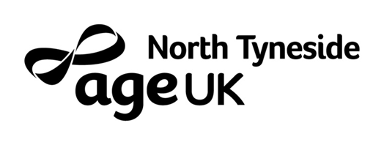

**INDUCTION**

**PLAN**

|  |  |  |
| --- | --- | --- |
| **Department / Service** | **Induction with department / service (Please tick appropriate box)** | **Date & Time arranged** |
| **HR** | MANDATORY | **First Day at 10:00** |
| **Executive Directors**  **(Meet and greet CEO where possible)** | MANDATORY | **HR to arrange** |
| **Care at Home / Extra Care Schemes** | Yes No |  |
| **Finance** | Yes No |  |
| **Quality & Performance/ CRM** | Yes No |  |
| **Trading – Age UK North of Tyne & Gateshead** | Yes No |  |
| **Integrated Care** | Yes No |  |
| **Wellbeing Centres** | Yes No |  |
| **Social Prescribing** | Yes No |  |
| **Dementia Services** | Yes No |  |
| **Catering Department** | Yes No |  |
| **Information & Advice** | Yes No |  |
| **Customer Services** | Yes No |  |
| **Volunteering** | Yes No |  |
| **Marketing** | Yes No |  |

I confirm that all departments / services are aware of the dates and times for the individual’s induction

**Signed by Line Manager** ………………………………. **Date** ………………………….

**Induction Completion date (max. 4 weeks post start date):** .................................

***HR USE ONLY***

|  |  |
| --- | --- |
| **HR received Induction Plan** | **Induction Schedule put together** |
| Date:  Signature: | Date:  Signature: |